**DAILY ONLINE ACTIVITIES SUMMARY**

|  |  |  |  |  |  |  |  |  |
| --- | --- | --- | --- | --- | --- | --- | --- | --- |
| **Date:** | **01-06-2020** | | | | | **Name:** | **Rohan Mahaveer** | |
| **Sem & Sec** | **6th B** | | | | | **USN:** | **4AL17CS077** | |
| **Online Test Summary** | | | | | | | | |
| **Subject** | | **CNSC** | | | | | | |
| **Max. Marks** | | **60** | | **Score** | | | **52** | |
| **Certification Course Summary** | | | | | | | | |
| **Course** | **Robotic Process Automation** | | | | | | | |
| **Certificate Provider** | | | **GUVI** | | **Duration** | | | **3 hrs** |
| **Coding Challenges** | | | | | | | | |
| Problem Statement: 1. write a python program to print number of uppercase and number of lowercase in a string  2. Python program to read a number and print the pattern | | | | | | | | |
| **Status:** YES, Completed all Programs | | | | | | | | |
| **Uploaded the report in Github** | | | | | **YES** | | | |
| **If yes Repository name** | | | | | <https://github.com/rohanmahaveer/daily-status> | | | |
| **Uploaded the report in slack** | | | | | **YES** | | | |

Online Test Details:

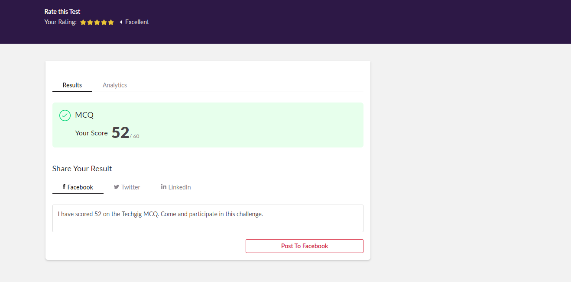

Scored 52 out of 60 in CNSC 2nd I.A test

Certification Course Details:

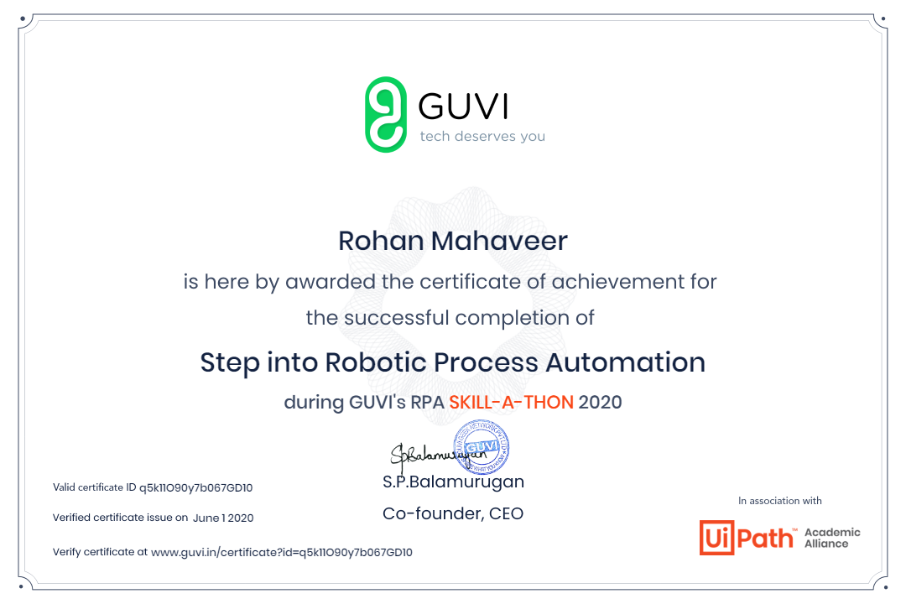

The above course is being taken up by me is based on Robotic Automation process. It started with the Introduction to RPA, Benefits of RPA, How to install the software and the first program was explained. The details of the course and certificate provider are mentioned in the above form.

Coding Challenges Details:

Program1:

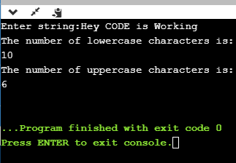

Program2:

